# Azure Managing Subscriptions

## **Tutorial**

In this tutorial, we will:

1. Create a new subscription
2. Ensure the correct Administrator permissions are applied
3. Create, and add a tag to, a Virtual Machine
4. Create a policy and apply it to your new subscription

using both the **Azure Portal** and the **CLI**.

First, we need to **create a new subscription**:

1. Search for subscriptions in the Portal search bar:

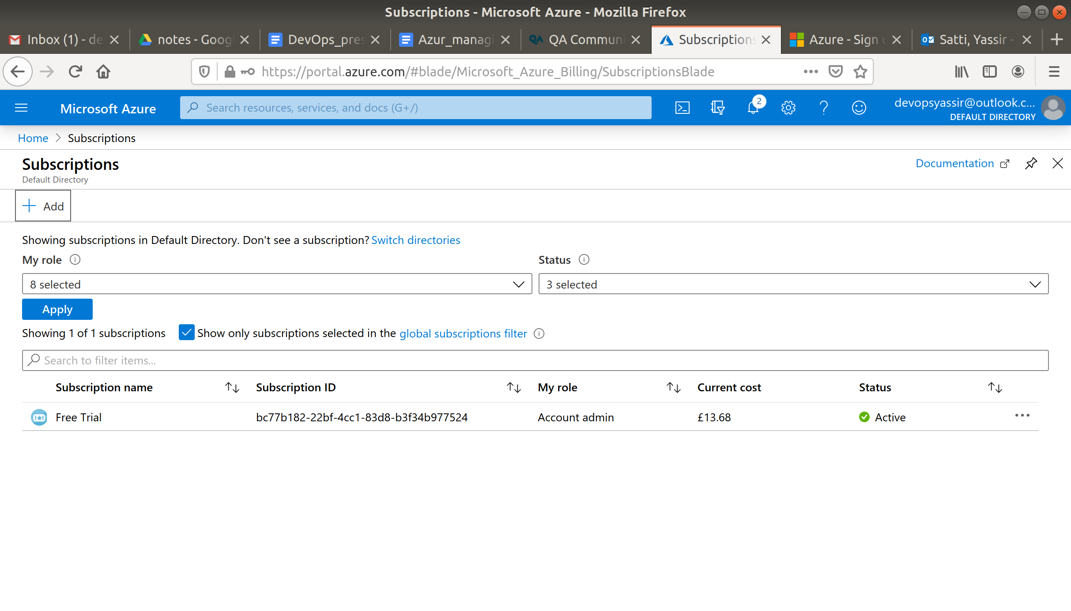

1. Click +Add:
2. Follow the steps in the new tab. Choose Free Trial and fill in your billing details. **You will not be charged**.

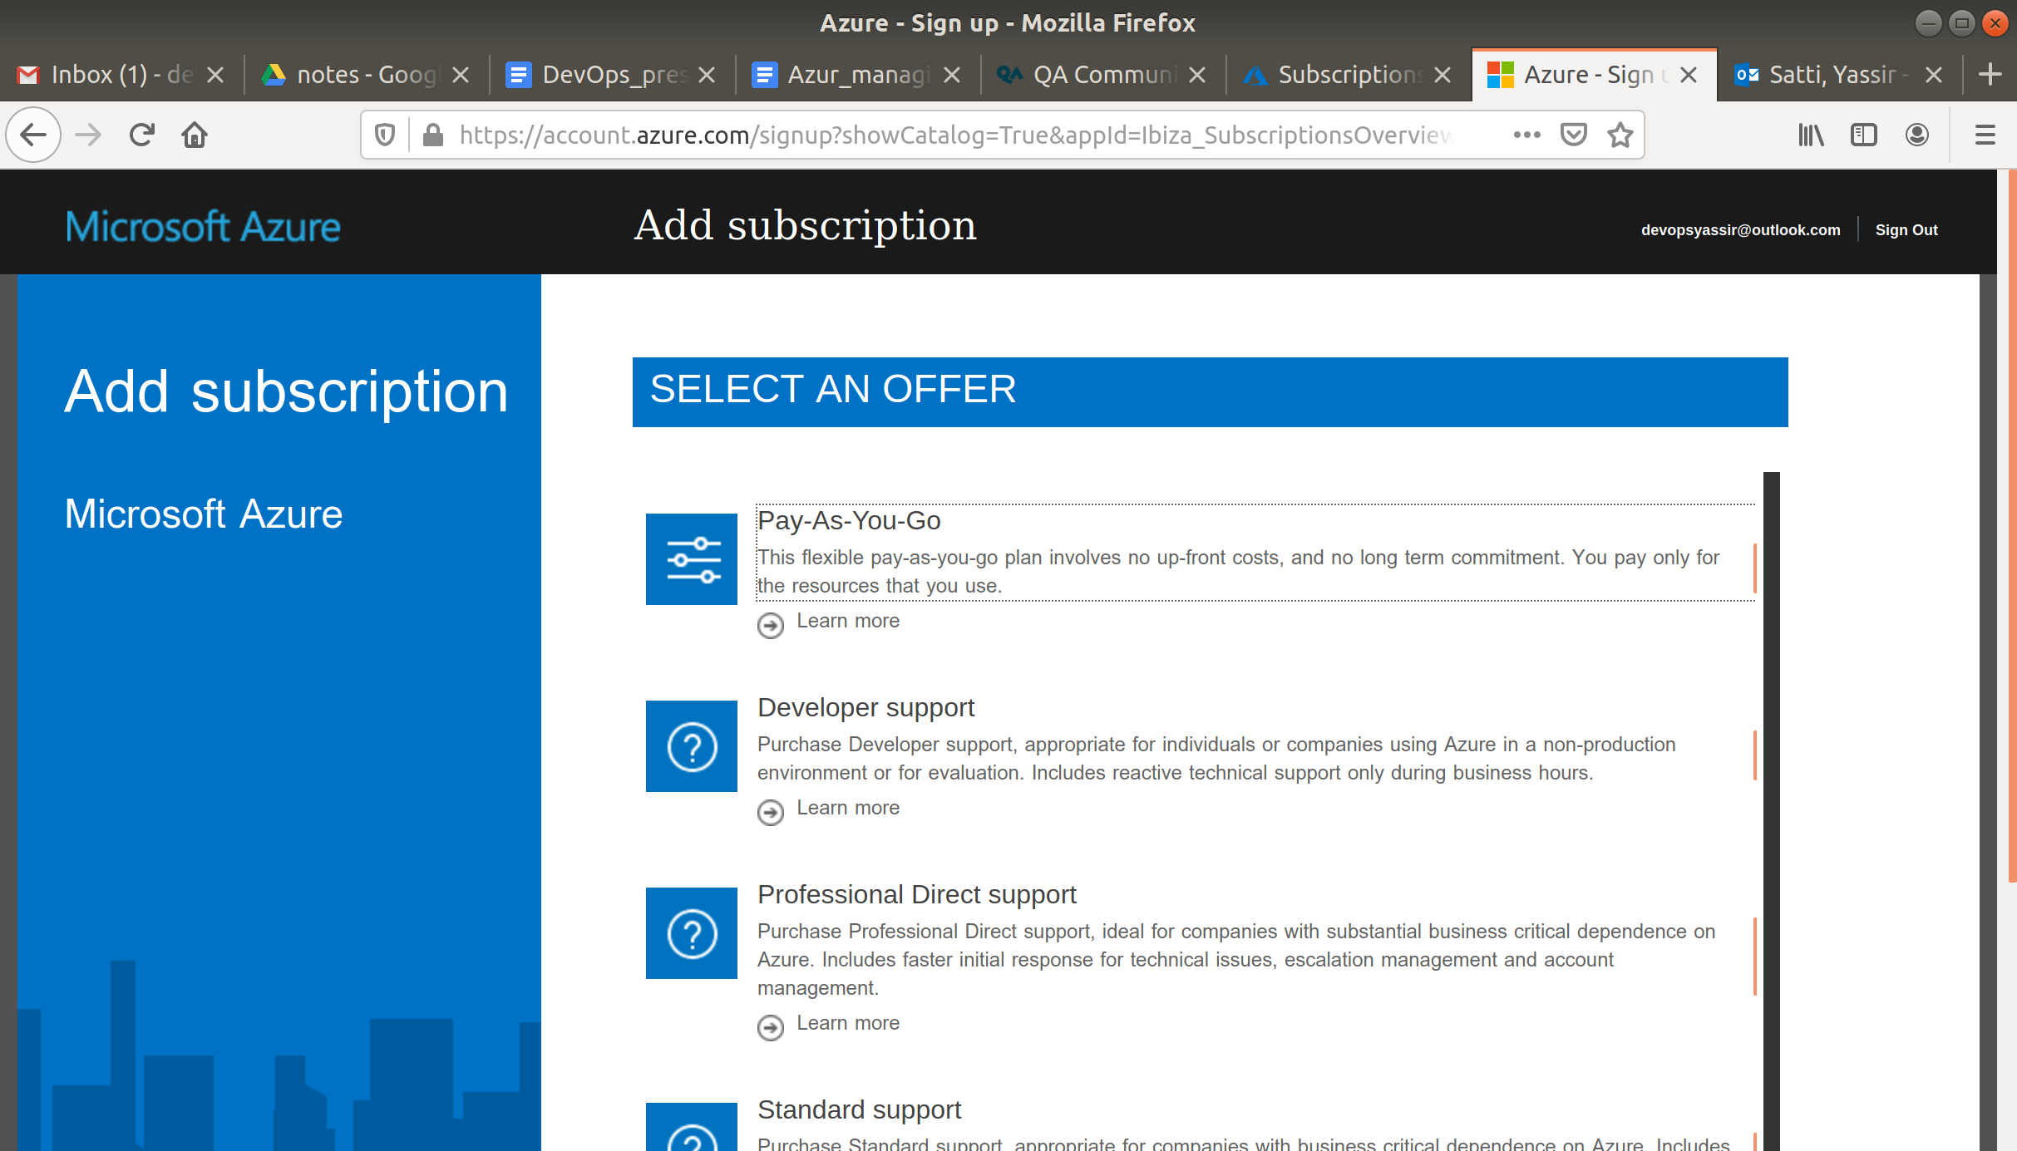

1. You Free Trial subscription should now show up in the Subscriptions page.

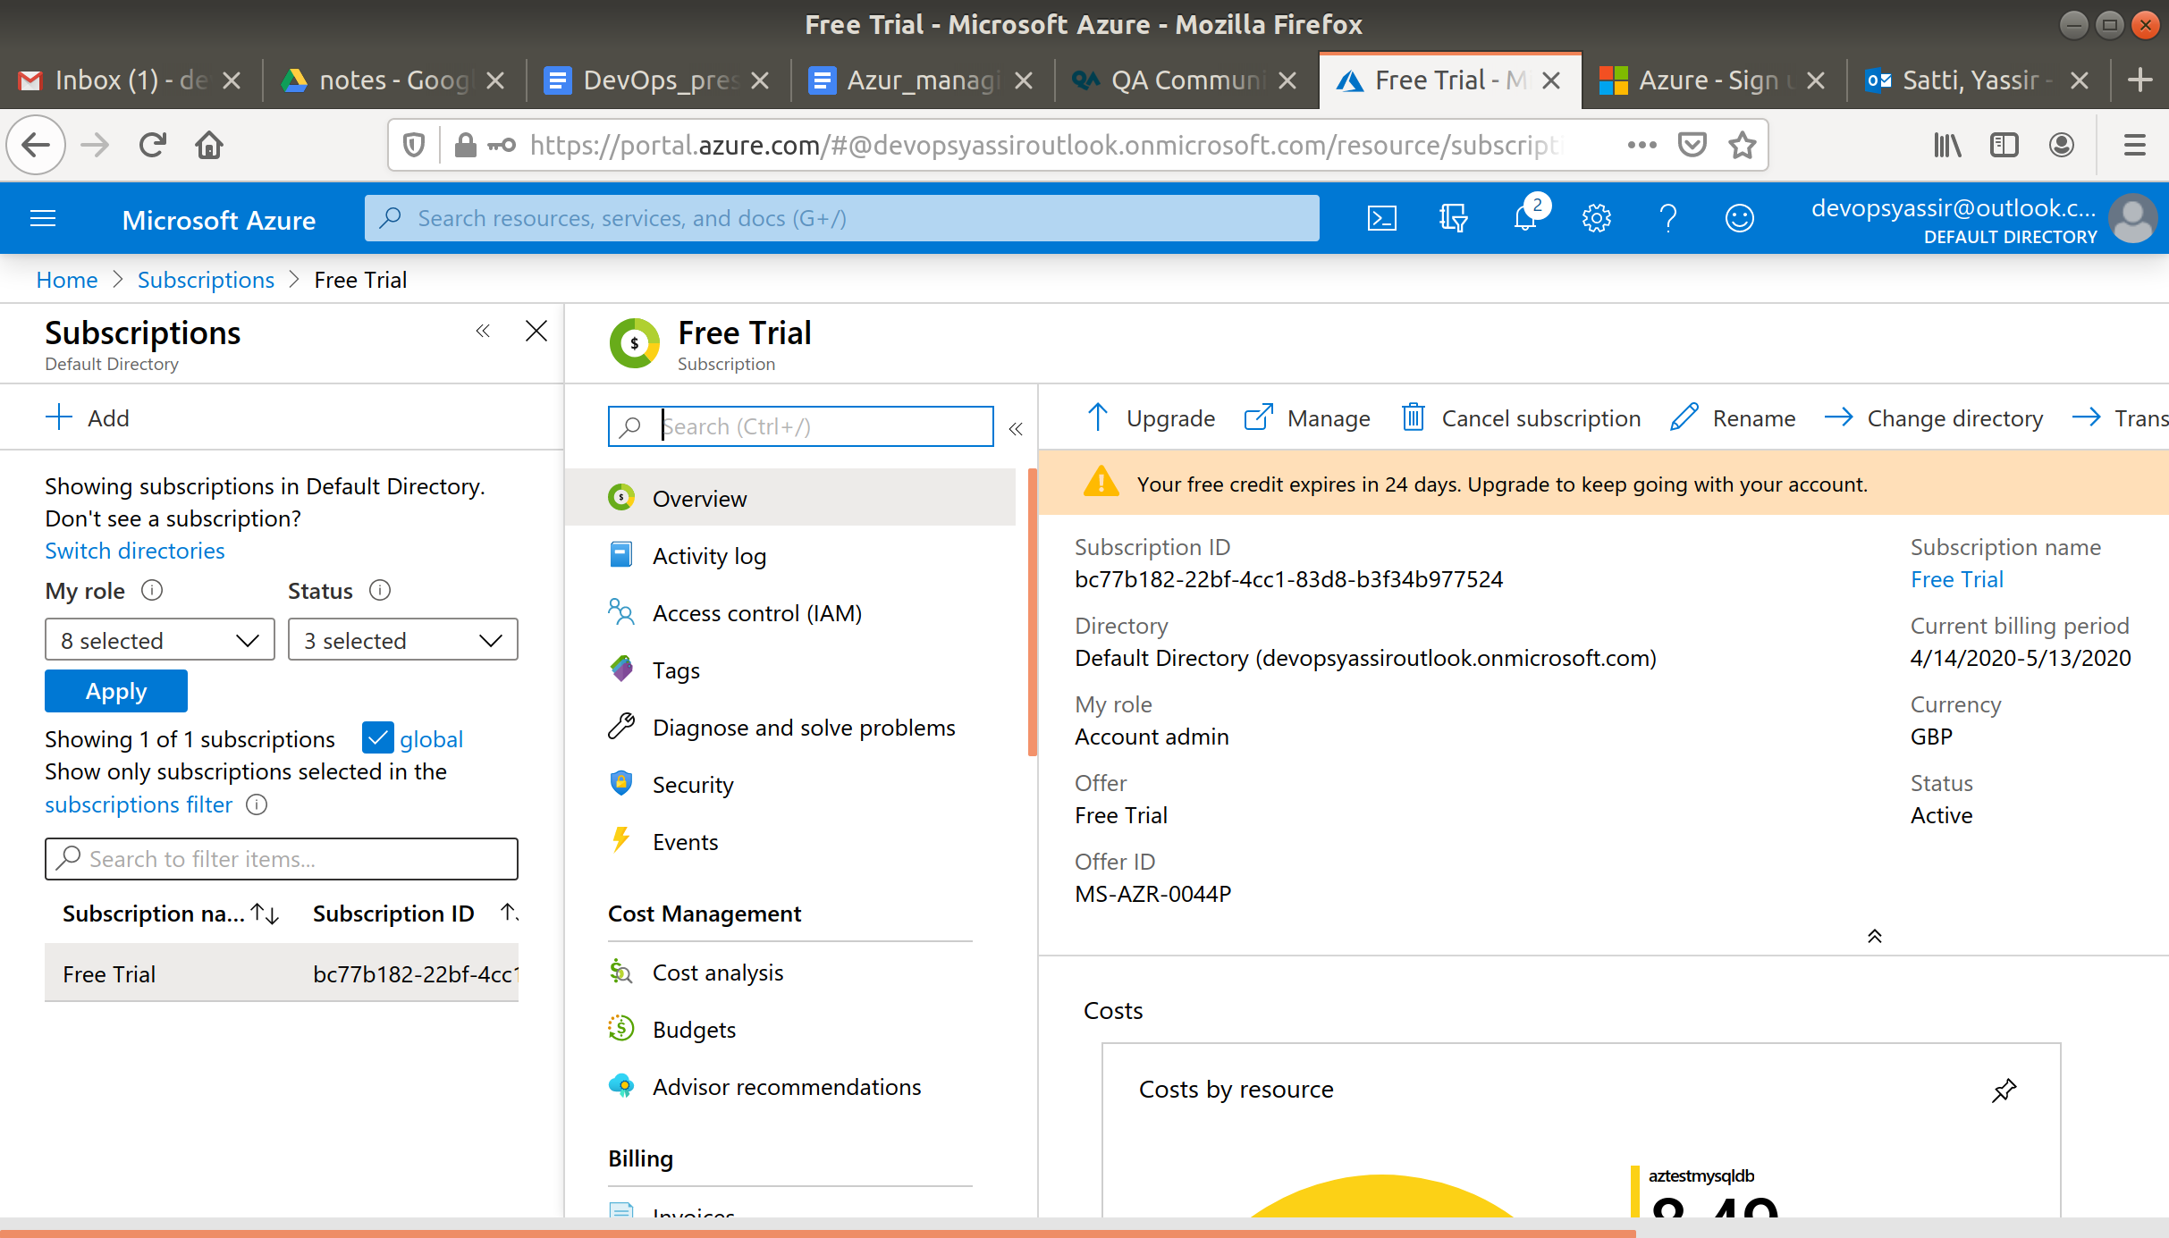

Next, we need to check our **Administrator Permissions**:

1. Go to your new subscription:

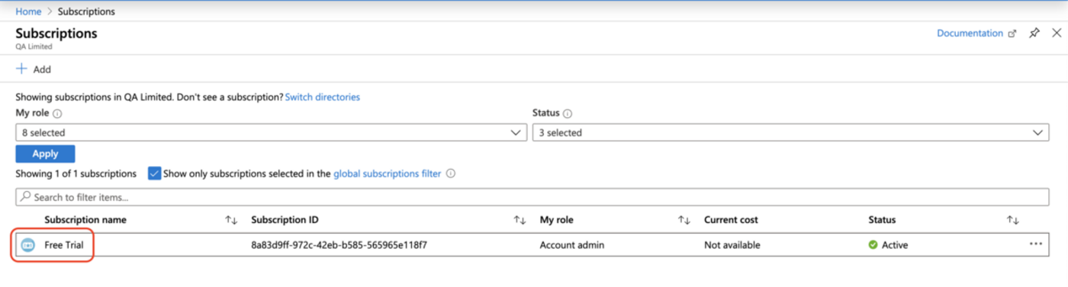

1. Go to IAM on the left hand side:

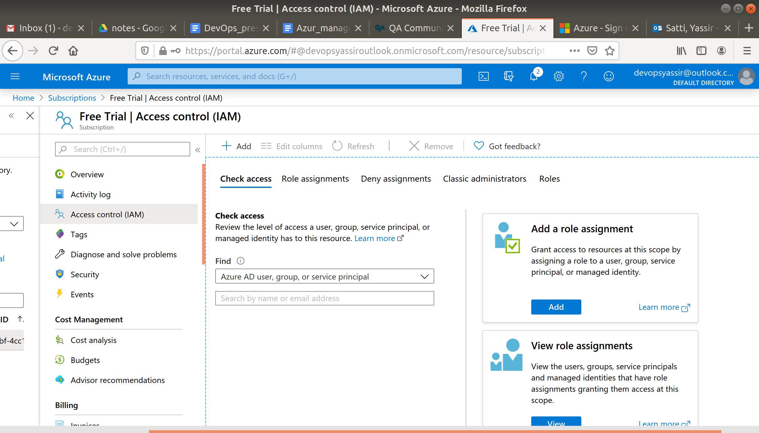

1. Click on "Classic administrators":
2. You should be able to see that you are a **Service Administrator** by default:

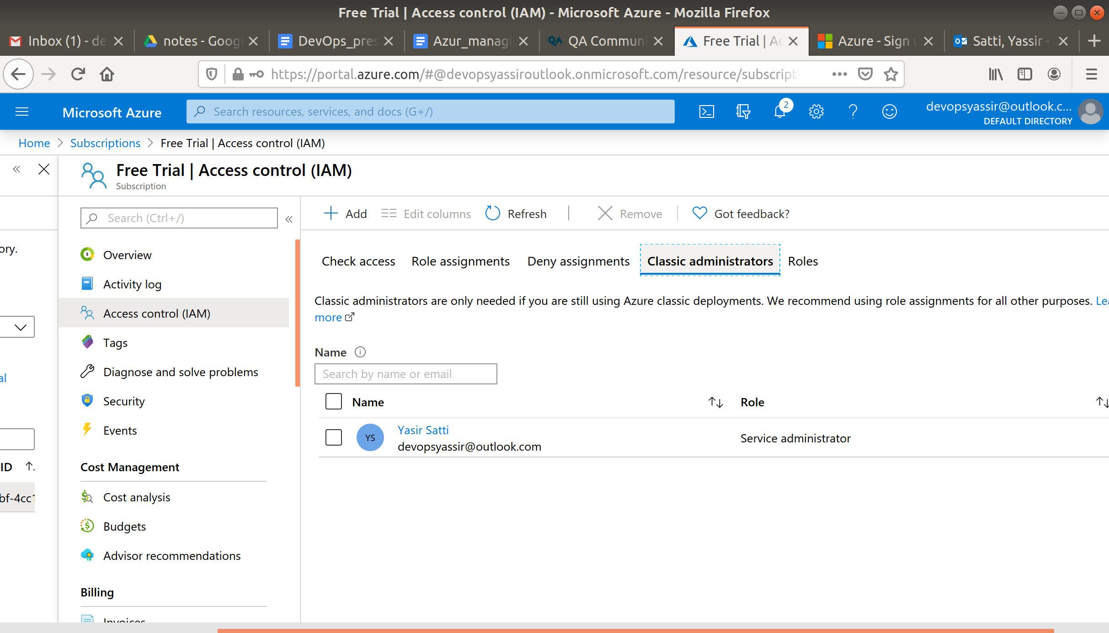

1. At this point, you could use the +Add button to add Co-Administrators if you wanted. These users would have to be in the current Active Directory.

Now, we need to change our subscription in the Azure CLI. This is so that any commands we run will execute inside the correct subscription:

**az account set --subscription <name or id>**

Of course, you will replace the <name or id> with your Subscription ID. This is found on the Subscriptions page.

Now, we can create a VM and add a tag:

1. Create a Resource Group:

**az group create -n admintest -l uksouth**

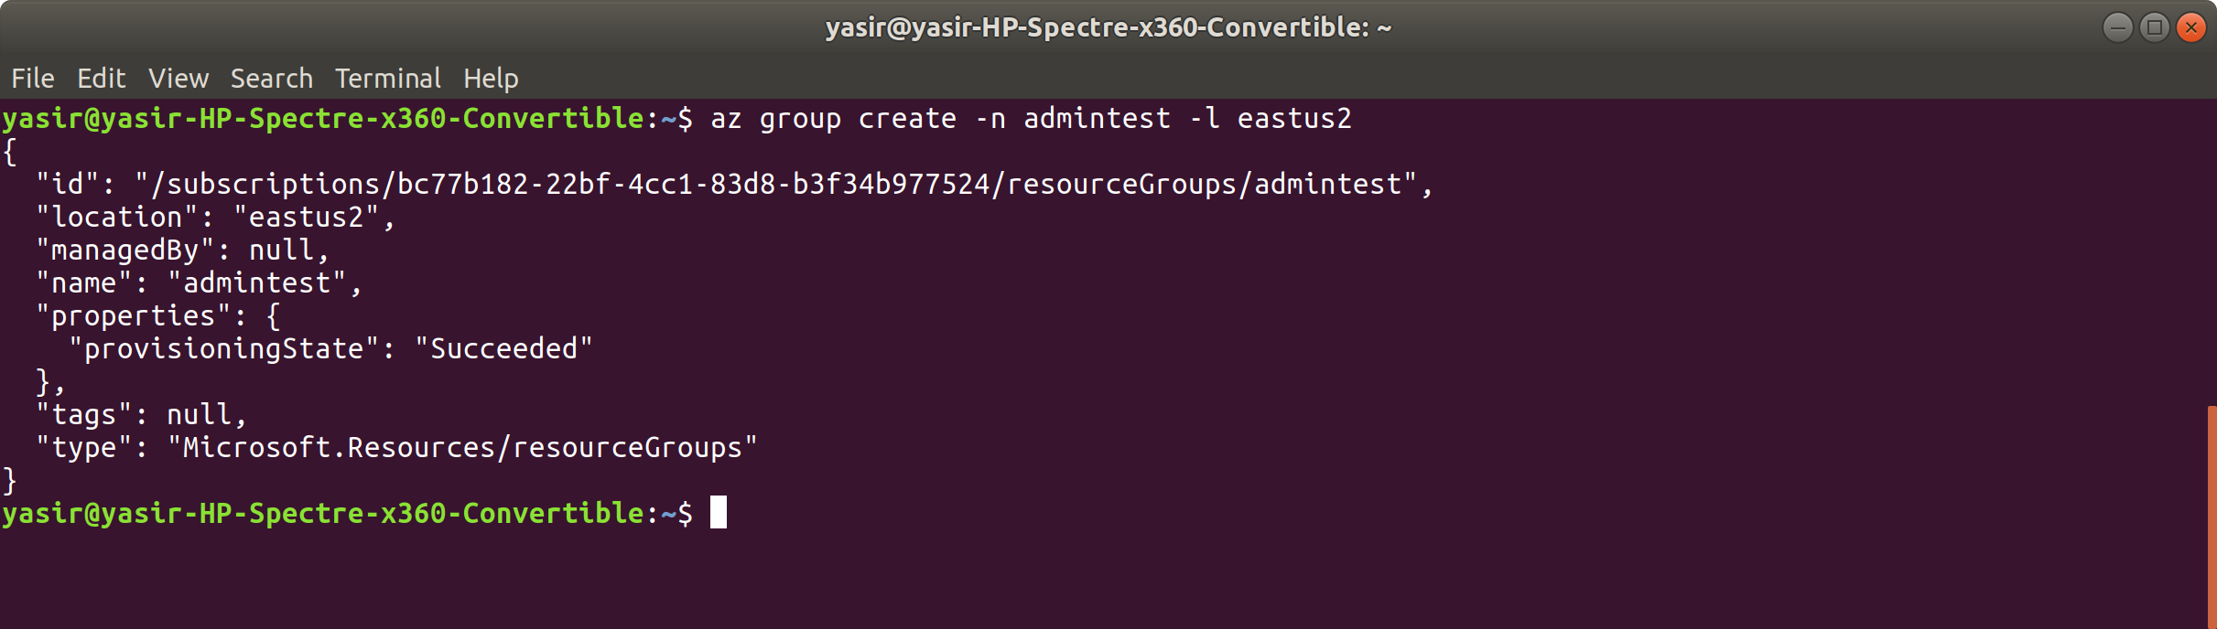

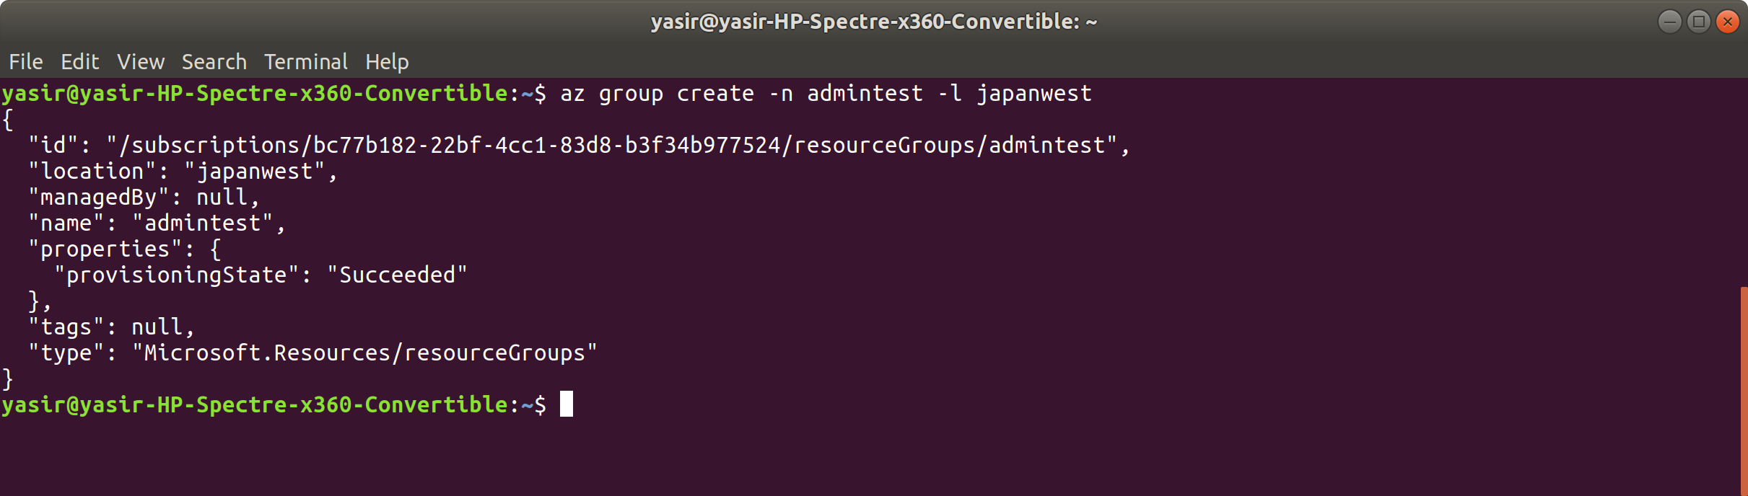

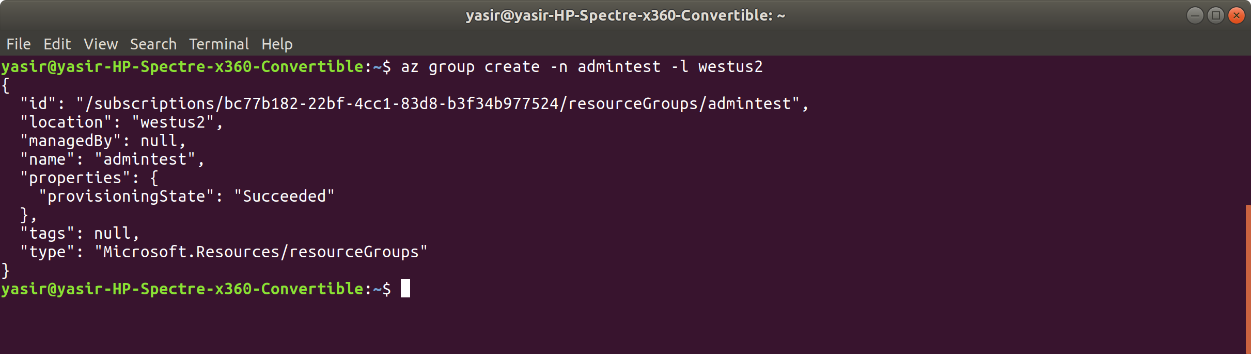

1. Create a VM with a tag added:

**az vm create -g admintest -n adminvm -l uksouth --image UbuntuLTS --tags 'Environment=Production'**

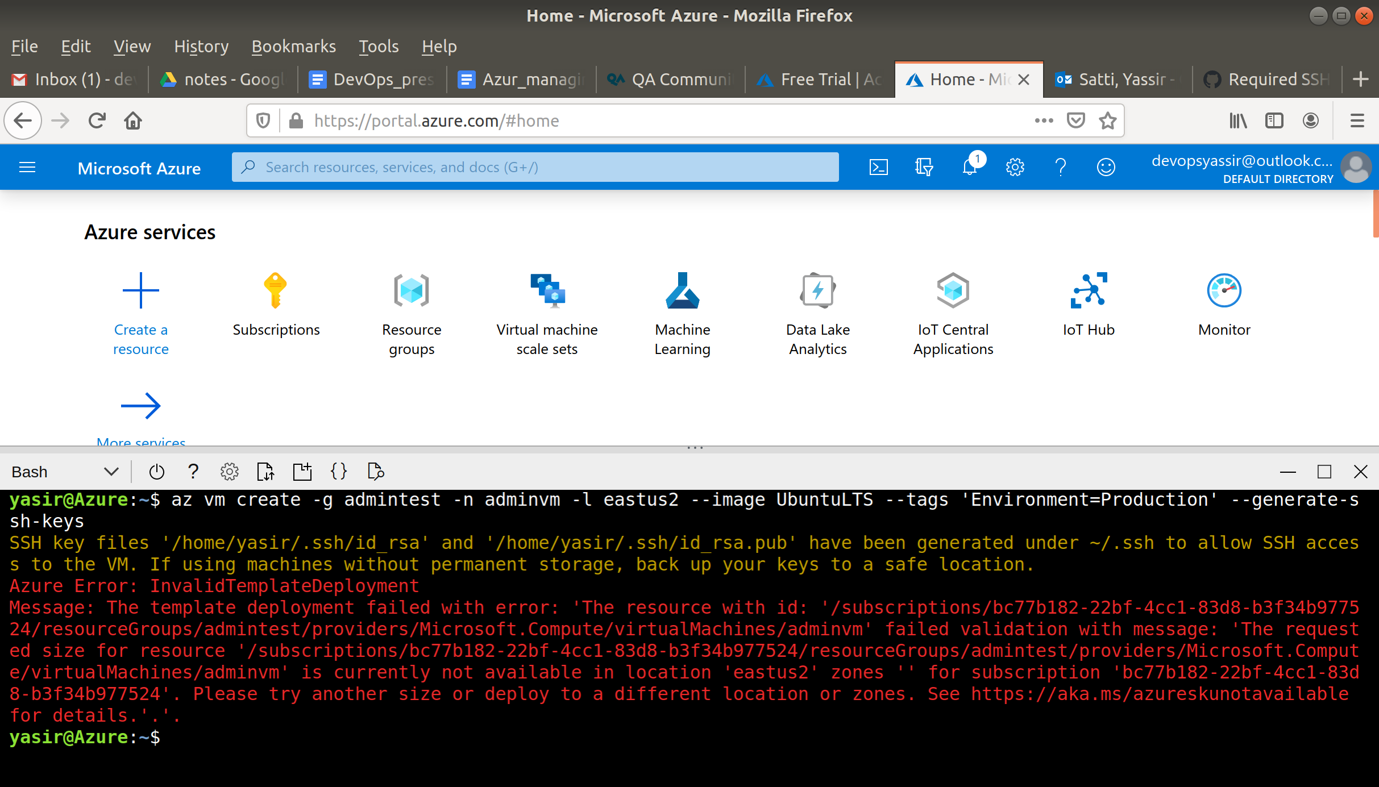

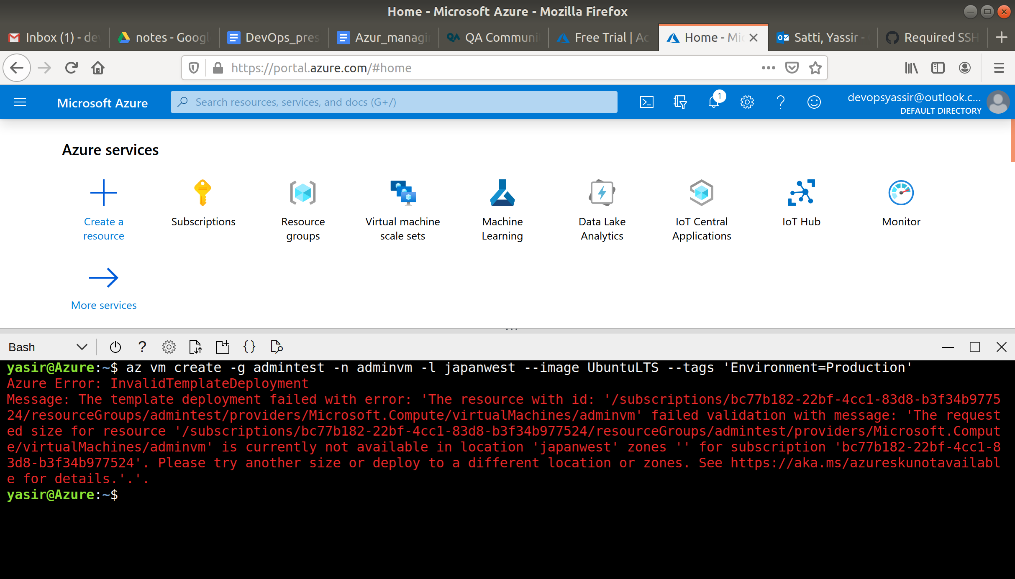

We are now ready to create a policy that ensures resources in the subscription have a tag for "**Environment**":

1. Search "Policy" in the search bar:
2. Click on "Assignments" and then "Assign policy":

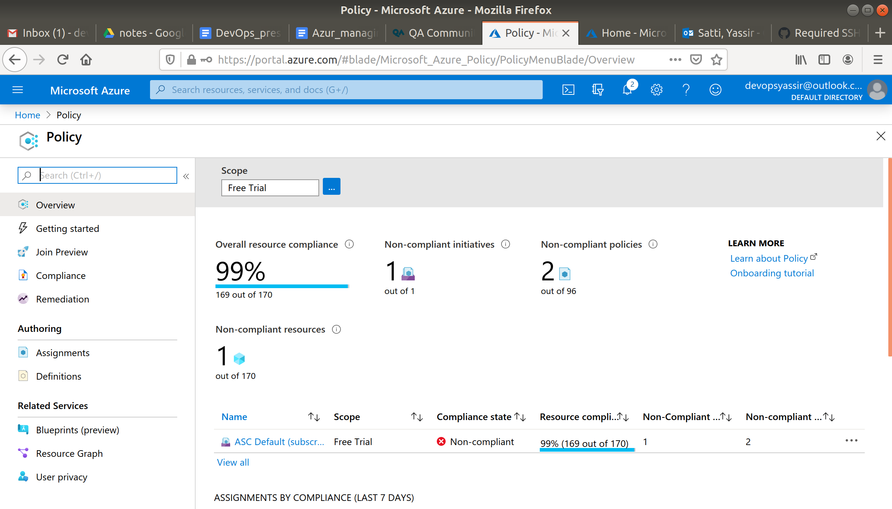

1. Fill this template in as below, and then click "Next":

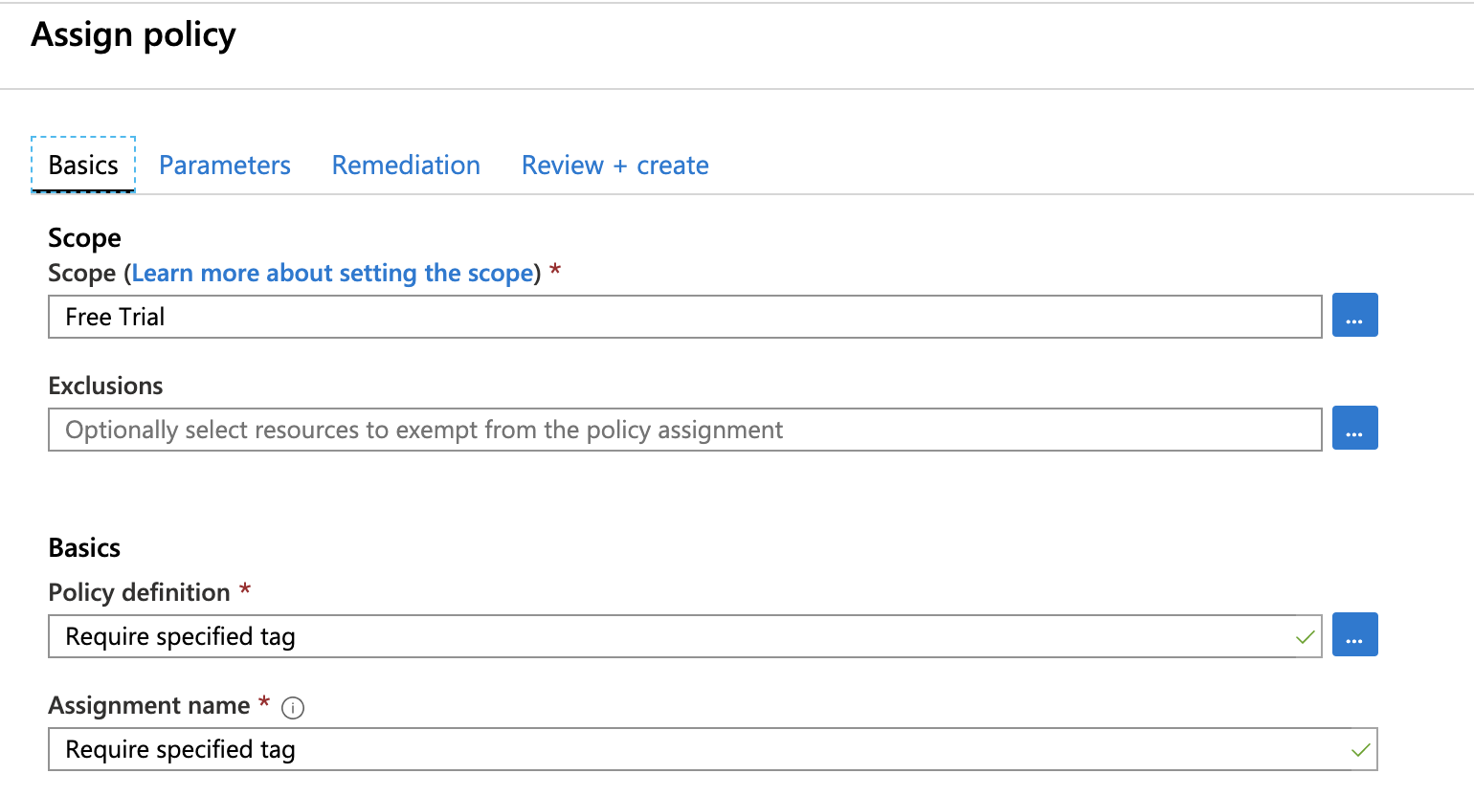

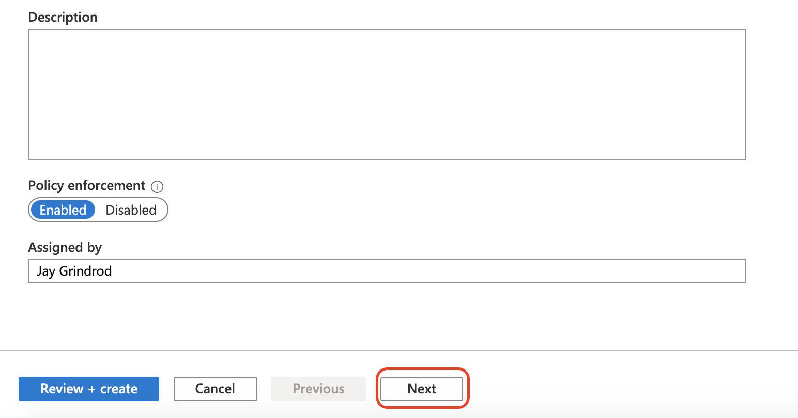

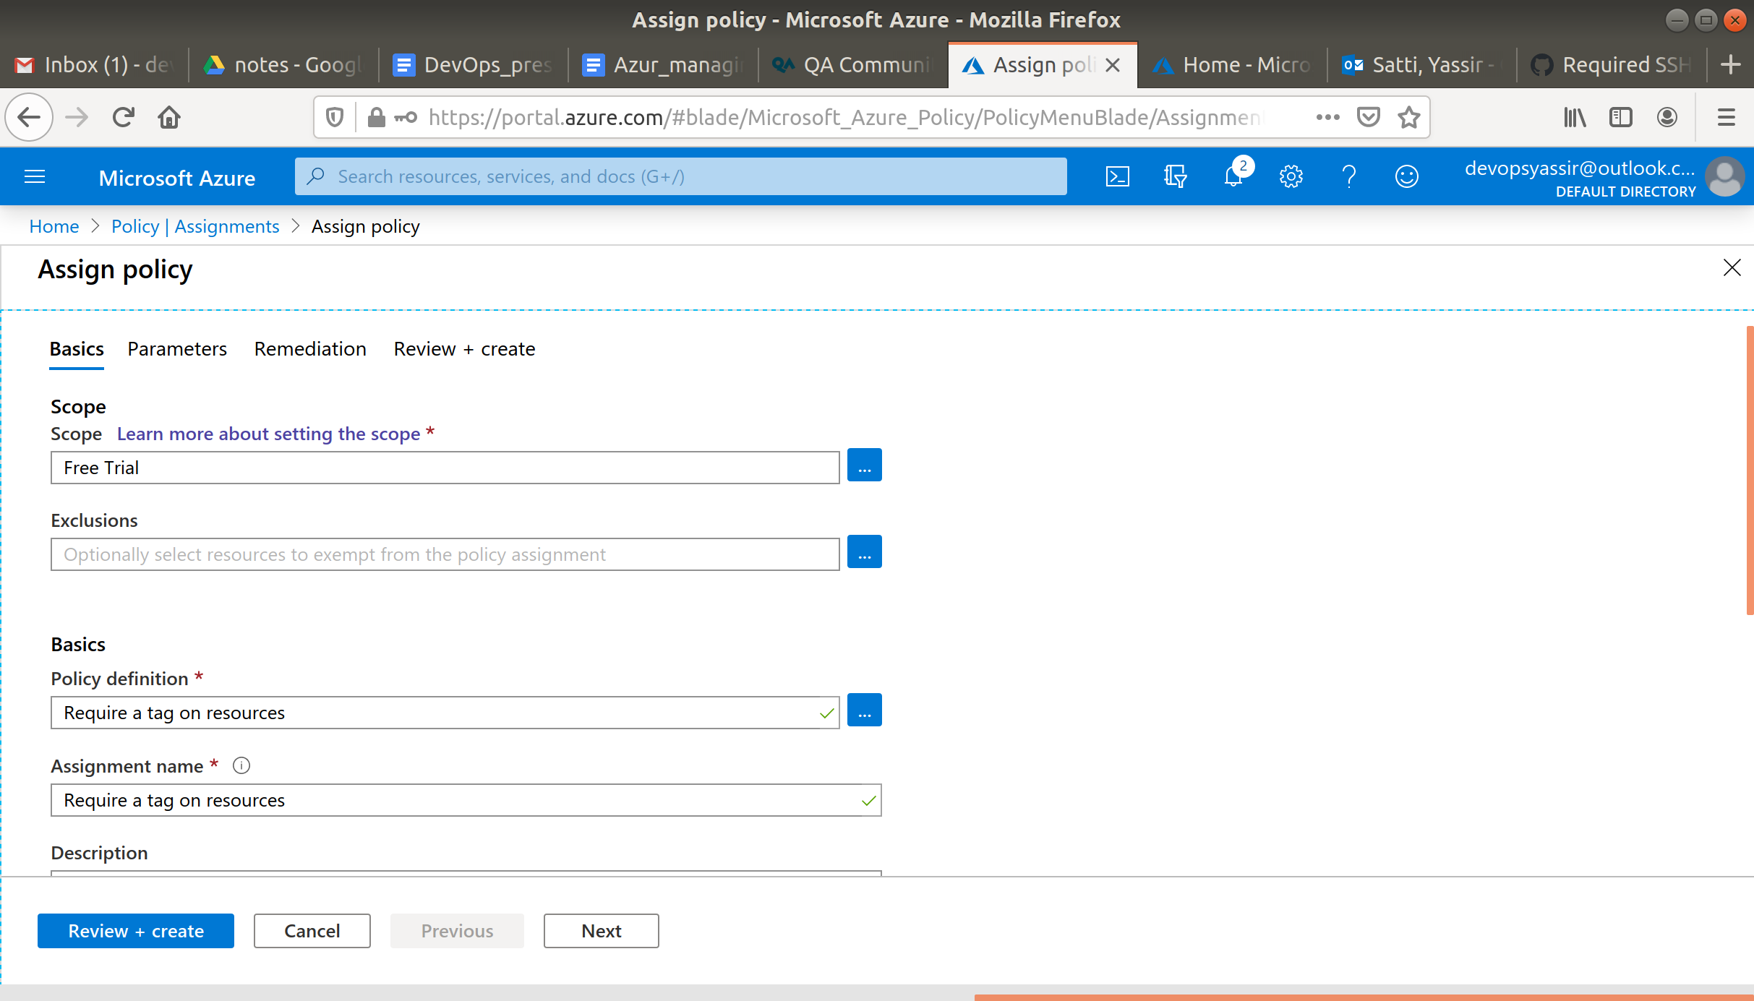

1. Enter "Environment" and click "Review + create":

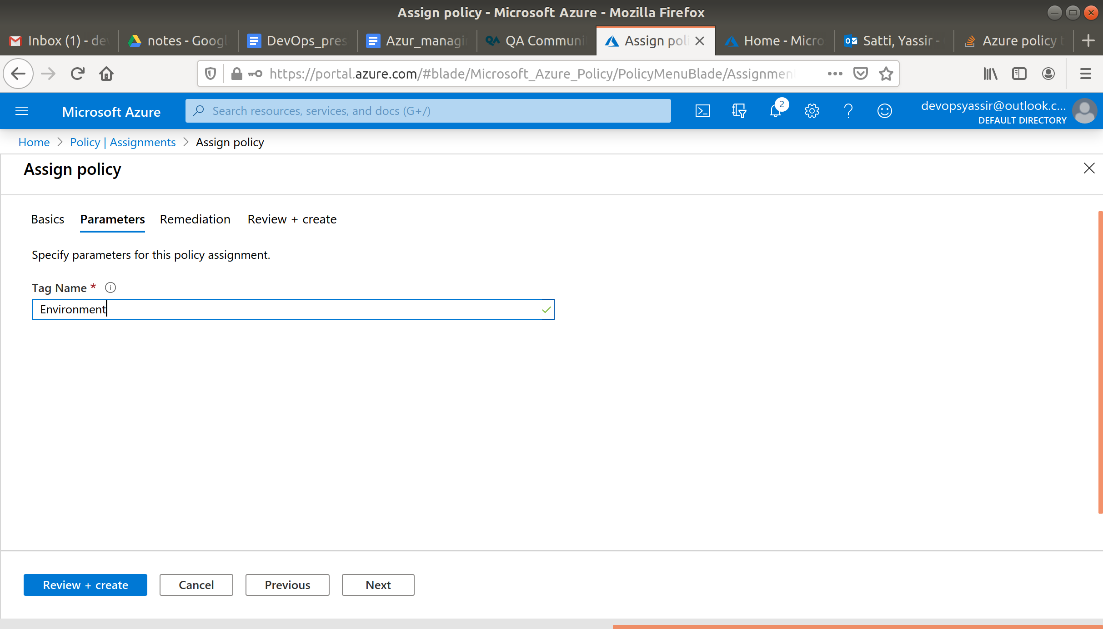

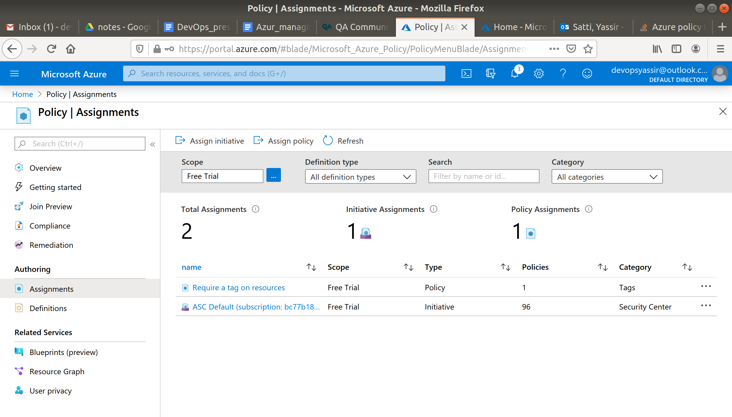

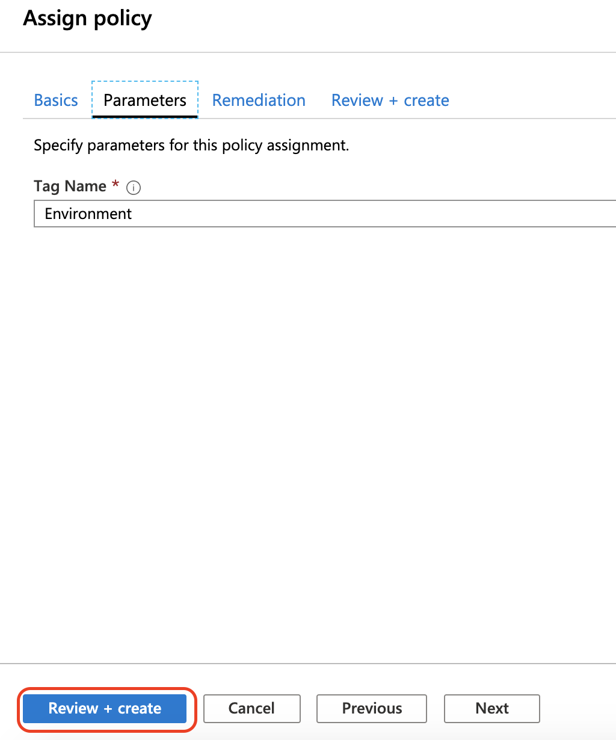

1. Click "Create"

**The policy will take around 30 minutes to become active!**

After around 30 minutes, we can go ahead and create a new VM without an "Environment" tag:

az vm create -g admintest -n adminvm1 -l uksouth --image UbuntuLTS

This deployment should **fail**!

Next, we will create the VM again, but this time add the "Environment" tag:

az vm create -g admintest -n adminvm1 -l uksouth --image UbuntuLTS --tags 'Environment=Production'

This time, **the VM should be created**.